Active Vocabulary

🗣️ What is Active Vocabulary
# Source: Chatgpt (GPT-4-turbo) at [7/30/2025]
Active vocabulary includes the words a person can both understand and use confidently in speaking and writing. These words are part of everyday expression and communication.

✅ Key Features:
# Source: Chatgpt (GPT-4-turbo) at [7/30/2025]
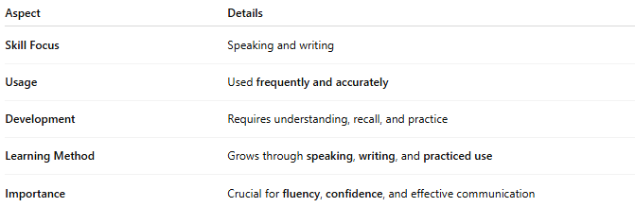
Aspect | Details
Skill Focus | Speaking and writing
Usage | Used frequently and accurately
Development | Requires understanding, recall, and practice
Learning Method | Grows through speaking, writing, and practiced use
Importance | Crucial for fluency, confidence, and effective communication

🧠 Example:
# Source: Chatgpt (GPT-4-turbo) at [7/30/2025]
- You write: “She made a wise decision.”
👉 You not only understand “wise”, but also use it correctly in context.

👤 Who Uses It?
# Source: Chatgpt (GPT-4-turbo) at [7/30/2025]
- Everyone who actively communicates, especially:
  - Native speakers in daily life
  - Language learners practicing output
  - Professionals, presenters, and writers

🔄 Active vs Passive Vocabulary
# Source: Chatgpt (GPT-4-turbo) at [7/30/2025]
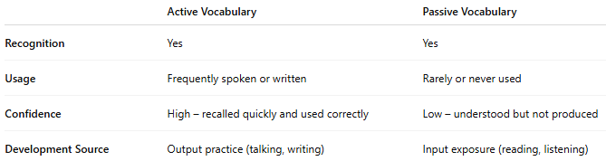
 | Active Vocabulary | Passive Vocabulary
Recognition | Yes | Yes
Usage | Frequently spoken or written | Rarely or never used
Confidence | High – recalled quickly and used correctly | Low – understood but not produced
Development Source | Output practice (talking, writing) | Input exposure (reading, listening)

Active Vocabulary vs Productive Vocabulary
# Source: Chatgpt (GPT-4-turbo) at [7/30/2025]

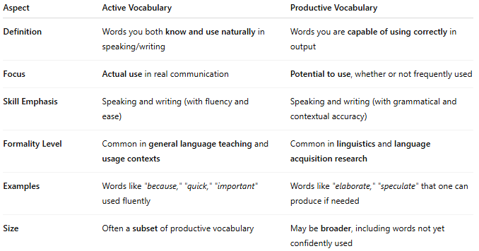
Aspect | Active Vocabulary | Productive Vocabulary
Definition | Words you both know and use naturally in speaking/writing | Words you are capable of using correctly in output
Focus | Actual use in real communication | Potential to use, whether or not frequently used
Skill Emphasis | Speaking and writing (with fluency and ease) | Speaking and writing (with grammatical and contextual accuracy)
Formality Level | Common in general language teaching and usage contexts | Common in linguistics and language acquisition research
Examples | Words like "because," "quick," "important" used fluently | Words like "elaborate," "speculate" that one can produce if needed
Size | Often a subset of productive vocabulary | May be broader, including words not yet confidently used

✅ Summary:
- All active vocabulary is productive, but not all productive vocabulary is truly active.
- Active vocabulary is what's regularly used in communication.
- Productive vocabulary includes all words you can use (even if rarely or with effort).

📌 Summary:
# Source: Chatgpt (GPT-4-turbo) at [7/30/2025]
- Active Vocabulary = Words you know + use
- Passive Vocabulary = Words you know but don’t use

